DOCUMENTATION, ASSESSMENT AND PLANNING RECORD
Context: |  |  |  | Individual observation of a 2-year 6 months child (A) on independent free indoor play in the construction corner. The child explored and experimented independently by stacking wooden blocks together to construct a tower.
DOCUMENTATION
A sat down in front of a basket of wooden blocks and began constructing them up slowly one on top of the other. He carried each block slowly, showing concentration and determination. After stacking four blocks, the tower collapsed. He paused and said, "oh, no! " before he began again, with his hands supporting the blocks. A nearby educator acknowledged his effort, saying, “You are trying a new way to make it stand. That’s clever thinking!” A smiled and built a taller tower with six blocks. He clapped when it stayed up.
ASSESSMENT
Each portion of the documentation above is to be reflected on and identified domains, milestones and dispositions must be linked to where the skill was demonstrated in the observation and referenced.
Domains |  |  |  |  | Milestones |  | Dispositions
- Cognitive development through Spatial reasoning, and problem-solving (Yang et al., 2020).  - Physical development through fine motor skills by hand–eye coordination (Beck, 2019).  - Language development by showing expressive language like "Oh, no! "  - Social and Emotional development by showing Confidence, persistence, and pride in achievement (Kasthoorie Dharmalingam, Sahani Dikkumbura, 2023). |  |  |  |  | - Child builds towers using multiple blocks  - Child uses two hands to manipulate materials  - Child uses single words to express ideas  - Chid shows persistence with tasks |  | - Curiosity  - Resourcefulness  - Confidence  - Perseverance
LEARNING and CURRICULUM
Each portion of the documentation is to be analysed for learning that is occurring and the curriculum areas the children are engaging in
Learning |  |  |  |  |  | Curriculum Areas
- Repeated building and rebuilding as a cause-and-effect understanding  - Development of problem-solving skills  - Self-correcting and effective confidence-building |  |  |  |  |  | - Mathematics  - Science  - Creative Arts  - Language and Communication
THEORY and FRAMEWORKS
Development and Education Theory |  |  |  |  |  | Early Years Learning Framework Principles, Practices, Outcomes
- Piaget theory of cognitive development: Sensorimotor and pre-operational stages which is through manipulation and use of symbol and language during play (McLeod, 2025b).  - Vygotsky: Scaffolding provided by educator’s praise which comes under zone of proximal development (McLeod, 2025a). |  |  |  |  |  | - Principles: Secure relationships, high expectations (Australian Government Department of Education, 2022).  - Practices: Learning through play, responsiveness to children, intentional teaching (AGDE, 2022).  - Learning Outcomes:  - Outcome 1.1: Children feel safe, secure, and supported (AGDE, 2022).  - Outcome 4.1: Children develop dispositions for learning such as persistence and confidence (AGDE, 2022).  - Outcome 4.2: Children use play to investigate, imagine, and explore ideas (AGDE, 2022).  - Outcome 5.2: Children use language to connect with others (AGDE, 2022).
PEDAGOGICAL SKILLS AND KNOWLEDGE
Each portion of the documentation is to be analysed for pedagogical skills and knowledge demonstrated by the educators.
Play-based Pedagogies |  |  | Teaching Strategies |  |  | EYLF Educator Evidence |  | Child Development
- Learning through open-ended and self-directed play  - Natural exploration of problem-solving and spatial reasoning |  |  | - Verbal encouragement to the child.  - Observation without interrupting the child.  - Scaffolding through acknowledgement of child’s effort. |  |  | - Creating supportive environments for experimentation.  - Observing and interpreting play as a learning opportunity.  - Encouraging self-confidence and resilience. |  | - Fine motor and cognitive growth.  - Social-emotional development through perseverance and self-regulation.
PLANNING
Objective for future holistic learning and development
To further enhance A’s spatial awareness, problem-solving skills, and persistence through intentional block-building activities.
Learning Experience
Learning experience name |  | "Make It Taller!" Exploring Design, Balance, and Height
Experience rationale |  | This experience helps to extend A’s interest in block play by supporting cognitive, physical, and language development through construction-based problem-solving. It encourages children to test theories and develop persistence when faced with challenges.
Development and learning goal: |  | - To support fine motor coordination through manipulation of various construction materials.  - To build understanding of spatial awareness, balance, and size.  - To encourage use of descriptive language and confidence for sharing achievements.
Experience outline: |  | Children are provided with different kind of block materials like wooden blocks, foam and cardboard in a designated construction space. Visual prompts like tall buildings and bridges will be available for inspiration. Educators will observe, interact through open-ended questions, and encourage children to reflect on their building process.
A list of materials required with photo(s): |  |   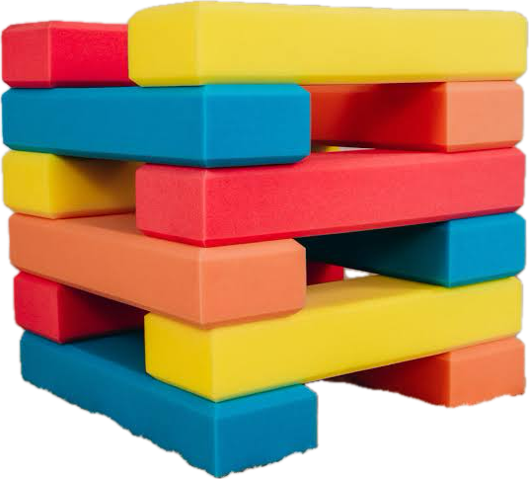  - Wooden and foam blocks.  - Picture cards of buildings/structures  - Measuring tape or ruler  - Mirror for side view of towers
EYLF child evidence links |  | - Outcome 3.2: Children take increasing responsibility for their own wellbeing (AGDE, 2022)  - Outcome 4.2: Children use play to explore, imagine, and investigate (AGDE, 2022).  - Outcome 5.1: Children interact verbally and non-verbally with others (AGDE, 2022).
Implementation plan | Introduction | Inviting A to explore the new blocks and recall his tower-building experience.
 | Body | Support A in experimenting with different stacking methods. Using prompts like:  • “What can we do to make it stand taller?”  • “What happens if you use a big block at the bottom?”
 | Conclusion | Celebrating his creation, asking how he built it, and document his responses.
 | Engagement questions | • “How did you build that?”  • “What happens when you use this one?”  • “Can you make it taller than before?”
ACTING and DOING
Play pedagogies |  |  | • Open-ended block play that supports experimentation and inquiry
Teaching strategies |  |  | • Scaffolding  • Verbal encouragement  • Modelling vocabulary like taller, wobbly and strong.
EYLF links |  |  | - Outcome 1: Children have strong sense of identity.  - Outcome 4: Children are confident and involved learners.  - Outcome 5: Children are effective communicators.
Child development |  |  | - Gross and fine motor skills  - Executive functioning and memory  - Confidence and emotional resilience
Documentation and/or digital evidence of implementation, acting and doing
REFLECTING and REVIEWING
How did the children respond? Did they achieve the learning objective? Were there any unexpected outcomes? What was your role? How did you support and teach the children? Would you do anything differently? Where to next?
A responded positively to the experience, showing focus, determination, and pleasure at her progress. He achieved the learning objective by demonstrating improved balance and fine motor control and confidently used words like “again” and “more” during the activity. My role was to provide encouragement, observe closely, and scaffold with minimal intrusion. If I repeated this experience, I would provide even more block types like cylinders or magnetic tiles to allow for varied architectural styles. Next, I plan to explore group building activities to encourage cooperation and shared problem-solving.

References

AGDE. (2022). Belonging, being and becoming: The early years learning framework for australia (V2.0). In ACECQA. https://www.acecqa.gov.au/sites/default/files/2023-01/EYLF-2022-V2.0.pdf

Beck, C. (2019, April 23). Development of eye-hand coordination. The OT Toolbox. https://www.theottoolbox.com/development-of-eye-hand-coordination/

Kasthoorie Dharmalingam, Sahani Dikkumbura. (2023, January 25). The Importance Of Social And Emotional Development In Children - THRIVE Project. THRIVE Project. https://thrivabilitymatters.org/social-and-emotional-development-in-children/

McLeod, S. (2025a). The zone of proximal development and scaffolding. Simply Psychology. https://www.simplypsychology.org/Zone-of-Proximal-Development.html

McLeod, S. (2025b, June 4). Piaget Cognitive Stages of Development. Simply Psychology. https://www.simplypsychology.org/piaget.html

Yang, W., Liu, H., Chen, N., Xu, P., & Lin, X. (2020). Is Early Spatial Skills Training Effective? A Meta-Analysis. Frontiers in Psychology, 11. https://doi.org/10.3389/fpsyg.2020.01938

