DOCUMENTATION, ASSESSMENT AND PLANNING RECORD
Context: |  |  |  | Small group observation of three children A, K and R aged 2.5–3 years during outdoor sandpit play. The children were provided with sand tools such as buckets, spades, shovel and moulds.
DOCUMENTATION
Running Record
Time | Observation
10:30 am | Child A, Child K, and Child R arrive at the sandpit and begin scooping sand into separate buckets.
10:32 am | Child A says, “I’m making cake,” and presses sand into a round mould.
10:34am | Child K watches and copies, saying, “Me too!”
10:35am | Child R digs a hole and says, look “It’s a tunnel!”
10:37 am | Child A hands a mould to Child K and says, “Here, you try.”
10:38am | The children laugh as their sand creations collapse. Child K says, “Oh no! It fell!”
10:39am | Child R sprinkles dry sand over the cakes and says, I add some “Sugar!”
10:40 am | They continue chatting, building, and problem-solving together.

ASSESSMENT
Each portion of the documentation above is to be reflected on and identified domains, milestones and dispositions must be linked to where the skill was demonstrated in the observation and referenced.
Domains |  |  |  |  | Milestones |  | Dispositions
- Social and Emotional development through cooperation, empathy, and sharing materials (Mayhew, 2024).  - Cognitive development through symbolic thinking and imaginative play (Mayhew, 2024).  - Language development through peer interaction, expressive vocabulary, and conversational skills (Mayhew, 2024).  - Physical development includes fine motor skills in scooping, packing, and manipulating tools (Mayhew, 2024). |  |  |  |  | - Engages in parallel and associative play.  - Uses imaginative language in play.  - Shares materials with peers and responds to social cues. |  | - Collaboration through Sharing and building together.  - Creativity by engaging in pretend cooking.  - Curiosity by experimenting with dry and wet sand.
LEARNING and CURRICULUM
Each portion of the documentation is to be analysed for learning that is occurring and the curriculum areas the children are engaging in
Learning |  |  |  |  |  | Curriculum Areas
Children are developing cooperative play skills, symbolic language, and creativity through sensory and imaginative sand play. |  |  |  |  |  | - Social Skills  - Early Literacy and Language  - Sensory and Physical Development  - Dramatic Play
THEORY and FRAMEWORKS
Development and Education Theory |  |  |  |  |  | Early Years Learning Framework Principles, Practices, Outcomes
- Vygotsky’s Theory of Cognitive Development: Social interactions with peer's support development within the zone of proximal development (McLeod, 2025).  - Piaget’s Pre-operational Stage of Cognitive Development: Symbolic representation during play indicates cognitive advancement in the pre-operational stage (Lally & Valentine-French, 2019). |  |  |  |  |  | - Principles: Respectful relationships and equity (Australian Government Department of Education [AGDE]. (2022).  - Practices: Intentional teaching and play-based learning (AGDE, 2022).  - Outcome 1: Children have a strong sense of identity (AGDE, 2022).  - Outcome 4: Children are confident and involved learners (AGDE, 2022).  - Outcome 5: Children are effective communicators (AGDE, 2022).
PEDAGOGICAL SKILLS AND KNOWLEDGE
Each portion of the documentation is to be analysed for pedagogical skills and knowledge demonstrated by the educators.
Play-based Pedagogies |  |  | Teaching Strategies |  |  | EYLF Educator Evidence |  | Child Development
- Open-ended sensory play as a platform for language and cognitive development.  - Child-led role play with minimal educator direction. |  |  | - Observation and gentle encouragement.  - Modelling vocabulary when appropriate like “That looks like a cupcake!” |  |  | - Supporting peer collaboration and social language use for children.  - Encouraging sensory exploration and creative thinking through play. |  | - Recognised value of pretend play for language and emotional expression.
PLANNING
Objective for future holistic learning and development
To further support children’s creativity, social language, and fine motor development through multi-sensory, cooperative sandpit experiences.
Learning Experience
Learning experience name |  | “Bakery in the Sand”
Experience rationale |  | Expanding children’s interest in sand baking and imaginative role play by introducing themed props and encouraging shared storytelling.
Development and learning goal: |  | - To strengthen peer collaboration and shared imagination.  - To enrich expressive language and storytelling during play.
Experience outline: |  | Setting up a sand “bakery” using bowls, whisks, muffin trays, and laminated recipe cards. Encouraging children to create “cakes,” “cookies,” and “sandwiches” while narrating their actions. Modelling vocabulary by introducing words like mix, scoop, bake, sprinkle, and decorate.
A list of materials required with photo(s): |  | - Real baking tools like spoons, muffin trays, rolling pins, whisks, and cookies mould.  - Laminated bakery signs and recipes  - Aprons and chef hats  - Loose parts like leaves, stones, and sticks for cake and cookie decoration.
EYLF child evidence links |  | - Outcome 5.2: Children engage in enjoyable reciprocal interactions using verbal and non-verbal communication (AGDE, 2022).  - Outcome 1.2: Children develop their emerging autonomy, interdependence, resilience, and sense of agency (AGDE, 2022).
Implementation plan | Introduction | Showing the children new “baking” tools and explain they can open a pretend bakery together. Inviting them to take on different roles like baker, customer, and decorator.
 | Body | Letting the children lead play while scaffolding their language and collaboration. Prompt storytelling or “orders” using recipe cards and signage.
 | Conclusion | Inviting the children to share what they made and reflect as a group: “What did you sell today?” “Who made the biggest cake?”
 | Engagement questions | - “What are you baking today?”  - “Can you show me how to decorate your cake?”  - “Can you make some cookies as well?”  - “What should we put in the oven next?”
ACTING and DOING
Play pedagogies |  |  | - Dramatic and imaginative sensory play.  - Role-based collaboration to develop social identity and communication.
Teaching strategies |  |  | - Encouraging descriptive vocabulary and pretend dialogue.  - Modelling rich language and facilitating turn-taking.
EYLF links |  |  | - Outcome 1: Children have strong sense of identity (AGDE, 2022).  - Outcome 4: Children are confident learners (AGDE, 2022).  - Outcome 5: Children are effective communicators (AGDE, 2022).
Child development |  |  | - Strengthening peer bonding, emotional regulation, and expressive language.  - Fine motor control and sensory exploration.
Documentation and/or digital evidence of implementation, acting and doing |  |  | 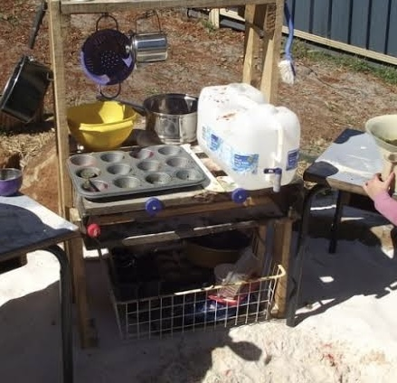  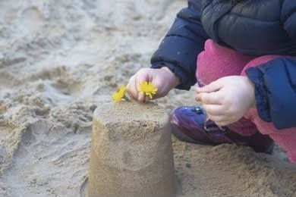  Real baking tools like spoons, muffin trays, rolling pins, bowl, and cookies mould.  Decorating cake with natural loose part like flower
REFLECTING and REVIEWING
How did the children respond? Did they achieve the learning objective? Were there any unexpected outcomes? What was your role? How did you support and teach the children? Would you do anything differently? Where to next?
How did the children respond?
For this activity, children showed deep engagement in sensory and social aspects of the experience by extending their roles, using creative language, and working together joyfully with educator and peers.
Did they achieve the learning objective?
Yes, they achieved their learning objective by displaying advanced pretend play and spontaneous cooperation while expanding their vocabulary.
Were there any unexpected outcomes?
Yes, one of the children created a sign for the “shop,” showing early literacy skills while another made a birthday cake and started a pretend party with peers.
What was your role?
As an educator my role was a facilitator and to language model, prompting descriptive words and role exploration without interrupting creativity.
Would you do anything differently?
Next time, I would like to incorporate diverse cultural foods and recipes to support inclusive storytelling and cultural awareness.
Where to next?
Next, we would Create a dramatic play area with a rotating theme like pizza shop, smoothie bar, market stand and so on based on children’s evolving interests.

References
AGDE. (2022). Belonging, being and becoming: The early years learning framework for australia (V2.0). In ACECQA. https://www.acecqa.gov.au/sites/default/files/2023-01/EYLF-2022-V2.0.pdf

Lally, M., & Valentine-French, S. (2019). Piaget’s preoperational stage of cognitive development. Lifespan Development. https://courses.lumenlearning.com/suny-lifespandevelopment/chapter/piagets-preoperational-stage-of-cognitive-development/

Mayhew, M. (2024, May 16). The Benefits of Sandpit Play for Toddlers. Milestones. https://milestones.com.au/news/sandpit-play-benefits-for-toddlers/

McLeod, S. (2025, March 18). Vygotsky’s sociocultural theory of cognitive development. Simply Psychology. https://www.simplypsychology.org/vygotsky.html

